April 25, 2022

**Employee Spotlight – Meet Kymberlee Stephens**

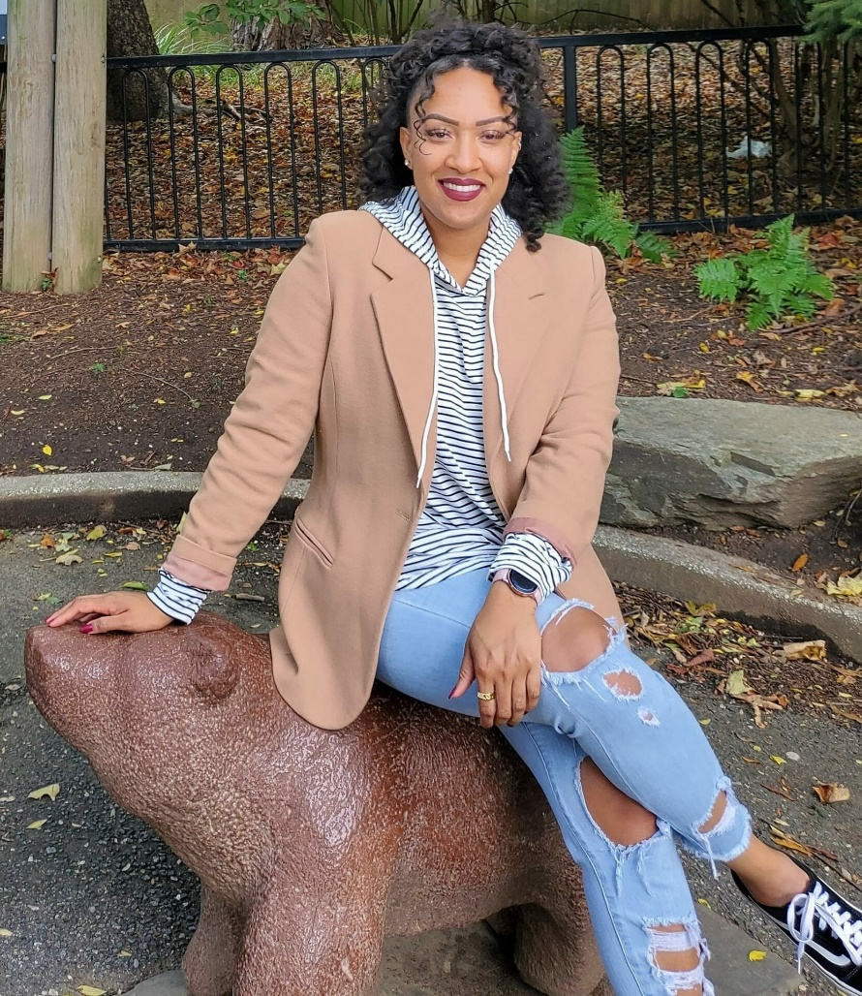

While our bread and butter is in technology, our roots were born in fitness and training through our non-profit, KidFit. KidFit uses athletics as a conduit to provide mentorship opportunities for all kids. With a personal trainer background, Kymberlee Stephens has been a natural fit in our family. She helps our team take full advantage of our wellness benefits and incorporate them into their every day lives. Read more about Kymberlee below!

**What does your career background look like? How did it lead you to where you are now?**

I’ve always been passionate about health and wellness. I received my bachelors in Exercise Science, and I began my career as a Certified Personal Trainer shortly after. I’ve loved being a Personal Trainer & helping people along their wellness journeys, but I’ve wanted to help people on a larger scale than 1:1 training allowed. That aspiration led me to the world of employee Benefits & Wellness, where I could build & design programs to help several people at once.

**What is your role at CloudFit Software?**

 As the Senior Benefits & Wellness Analyst at CloudFit, I’m responsible for administering the benefit plans, designing the employee wellness program, and organizing employee engagement opportunities. But most of all, I’m here to support employees and their families make the most of their total rewards package.

**What’s the best thing about your job?**

Because of my role, I get to support people through their happy life changes like having a baby or getting married, as well as tough times like taking care of a sick family member. In these times, I enjoy having the opportunity to be a support system and a liaison that makes navigating insurance & benefits as easy as possible.

**What surprised you most about working for CloudFit?**

 How great the people of CloudFit are. I’ve worked in a lot of different settings and the culture at CloudFit is so unique; I remember thinking “wow everyone here is so nice and down to earth!”

**What would you say is CloudFit’s biggest strength?**

 CloudFit’s biggest strength is the people. Everyone is so smart & talented. There’s so much I can learn (and have been learning) from those around me, by working here.

**What’s been one of your proudest moments working at CloudFit?**

 One of my proudest moments was organizing an employee lunch at our corporate office. Seeing everyone get together on the rooftop, and fellowship with their colleagues was rewarding.

**What are five words (or a short sentence) of advice for others in your profession?**

 Take time to connect with the people you support.

**What do you like to do when you’re not at the office?**

Outside of work I enjoy going to the gym/boxing, trying new food, reading, watching movies (good and bad), and spending time with my family.

Filed Under: [Uncategorized](https://www.cloudfitsoftware.com/category/uncategorized/)